Teresa Duncan, MS, FADIA, FAADOM

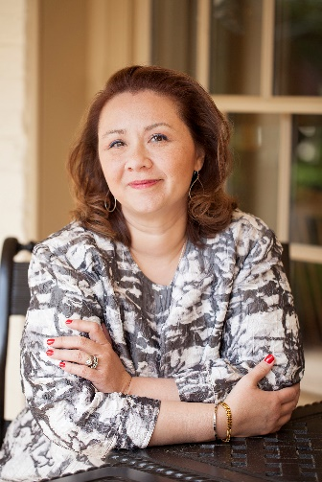
Teresa is a speaker and writer with over 20 years’ experience in healthcare. Her areas of expertise include revenue protection using proven accounts receivable and insurance methods; and helping doctors and managers establish solid management systems. Recently bestowed the award of Educator of the Year by the Association of Dental Implant Auxiliaries – a component of the International Congress of Oral Implantologists, she understands the importance of continuing education.

Currently she is the Insurance Editor for Dental Product Reports magazine and a contributor to The Progressive Dentist and Dr. Bicuspid. Teresa serves a founding Trustee for the auxiliary-learning focused DALE Foundation. She is a member of the Association of Certified Fraud Examiners, Academy of Dental Management Consultants, and the National Speakers Association. She is a proud Lifetime member and Fellow of the American Association of Dental Office Management and was the founding host of their popular Virtual Study Club.

She was recently named one of the Top 25 Women in Dentistry by Dental Products Report Magazine and is recognized as a Leader in Consulting by Dentistry Today. Most recently she provided consulting assistance in the development of the American Dental Association's Guidelines for Practice Success™. Teresa received her Master’s Degree in Healthcare Management from Marymount University.

Short description: (less than 90 words)

With over 20 years of healthcare experience, Teresa addresses topics such as Insurance Coding, Office Manager Training and Revenue Growth and Protection. She is a Fellow and Educator for the Association of Dental Implant Auxiliaries and the American Association of Dental Office Management. Her memberships include the Association of Certified Fraud Examiners, National Speakers Association and the Academy of Dental Management Consultants. She was recently named one of the Top 25 Women in Dentistry. Teresa received her Master’s Degree in Healthcare Management.
Shorter description: (less than 55 words)
Teresa is an international speaker who focuses on revenue & management issues. She is a Fellow of the American Assn of Dental Office Management. Her memberships include the National Speakers Association and the Academy of Dental Management Consultants. She holds a Master’s Degree in Healthcare Management.

